

**Faculty of Engineering and Applied Science**

**Department of Automotive, Mechanical, and Manufacturing Engineering**

MECE 3320U: Fluid Power Systems Project

Excavator Design

Course Instructor: Dr. Fereydoon Diba

Date: April 9, 2016

Group 20:

Michael Grifoni 100459826

Yongan Guo 100473235

Roy Alda 100398864

David Gambin 100487075

Contents

1- Introduction 3

2- Calculations 5

2A Kinematic Design 5

2B Cylinder Force Requirements 8

2B-1 Boom Cylinder Force Requirements 8

2B-2 Bucket Cylinder Force Requirements 11

2B-3 Stick Cylinder Force Requirements 11

2B-4 Cylinder Stroke Calculations 13

2C Pump Selection 16

2D Fittings and Head loss 17

2E Hydraulic Cylinder Dimensions 20

2E Safety valves 21

3- Design of the Hydraulic systems 22

3A Hydraulic Schematic Diagrams 22

3B Selections of DCVs for Joysticks Application 22

3C Advantages and limitations of your design 28

3D Maintenance schedule 29

4- Component selection 30

5- Appendix 37

6- References 45

# 

# 1- Introduction

Fluid power deals with the generation, control, and transmission of power using pressurized fluids. Since its discovery in 1650, innovations have been designed to allow people to perform work in a much easier manner. An example of a fluid power system in action is an excavator. The motor of the excavator is used to drive the positive displacement pump, which sends fluid to the cylinders which control the motion of the boom, stick, and bucket. In this project, research and design of a fluid power system is conducted and incorporated in an excavator.

### Problem description

The goal of this project is to design a hydraulic system that will rotate 3 links, i.e. boom, stick, and bucket, about their axes of rotation. Each link should be independently controlled and consist of a hydraulic cylinder and require control valves, fittings, hoses, and safety valves. The system must work independently from the existing actuators and drives installed in the excavator. The fluid used has a specific gravity (SG) value of 0.9 in SG kinematic viscosity of 100cS. The boom, stick, and bucket are design with safety factor 1.5 as an industry wide paradigm.

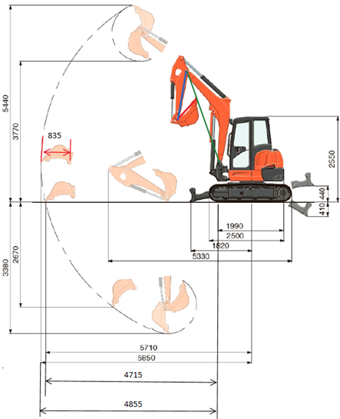

Figure 1 - Excavator Schematic: depicts dimensions of required bucket range

Important aspects that are solved in the report include the:

* Size and weight of boom, stick, and bucket
* Force acting on boom cylinder, stick cylinder and bucket cylinder
* Operating weight
* Bucket capacity
* Stick maximum digging force
* Bucket maximum digging force
* Safety factor of 1.5
* Type of pump that can provide flow rate at 120.6 LPM (118 is the popular excavator size) or larger
* DCV type and pipe and house (thin or thick wall)
* 3 of the 3/2 way DCV
* Gear pump that can provide required flow rate

# 2- Calculations

### 2A Kinematic Design

Before finding the maximum forces required from the cylinders, it was imperative to find the link lengths and to understand the geometries for when the cylinders would experience the maximum amount of load.

For kinematic analysis, it can be seen in Figure 1 that the boom, stick, and bucket have been approximated to the green, blue, and red lines respectively. The radius of the bucket in Figure 1 was found to be 835 mm. The stick length to 1500mm; from the stick’s axis of rotation to the buckets axis of rotation. Noting the fact that the tip of the bucket must reach 4855 mm from the boom axis of rotation, led to the stick length value.

The following figure is a simplified schematic of the boom, stick and bucket when the bucket is at its maximum reaching distance. Highlighted in yellow is the distance (2780.5 mm) from the axis of rotation of the boom to the axis of rotation of the arm; hence the length of the boom from pivot point to pivot point. The entire length of the boom is 3068 mm.

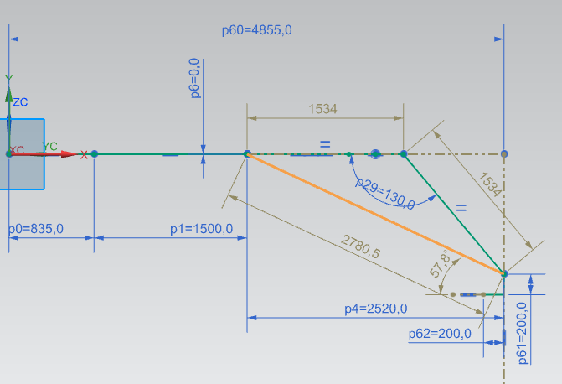

Figure 2 - Simplified Schematic with Bucket tip at max radius

Figure 3 depicts the boom designed in NX, where center of gravity for the boom was assumed to be located at the midpoint of the boom. After assigning a material of steel to the boom and meshing the object, the solid properties check function was used to find the mass of the boom to be 116.2 kg.

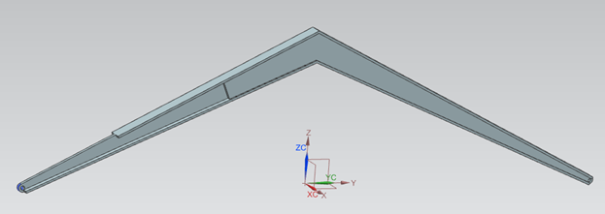

Figure 3 - Boom Design

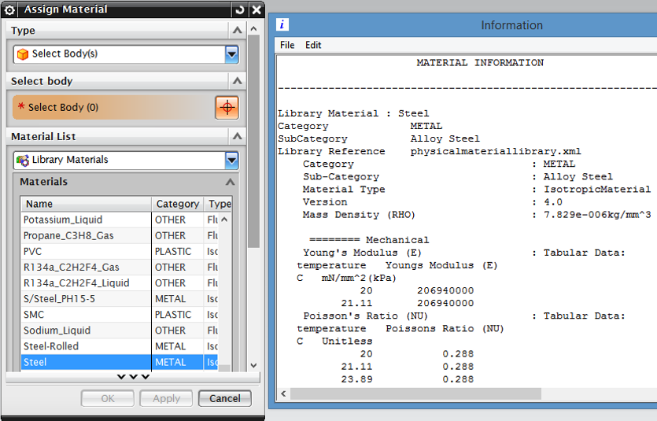

Figure 4 - Solid Properties given to Boom and Stick

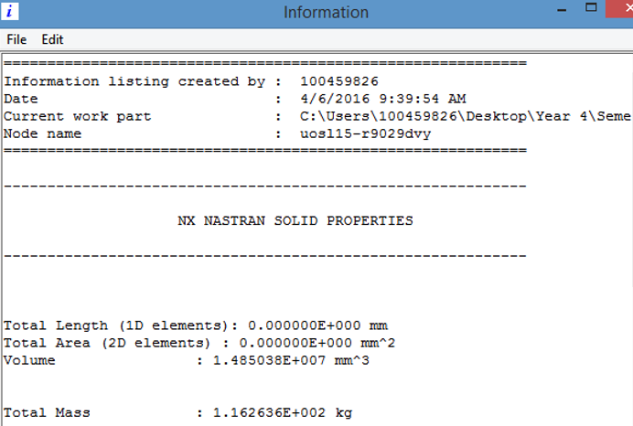

Figure 5 - Mass of boom

The stick was designed primarily as an I-beam with a slight modification at its axis of rotation. The modification at the end of the arm allows for the stick to be parallel with the boom as depicted in Figure 2. The same procedure was carried out to find the mass of the stick; assigned as material of steel and mass found to be 53.2kg. The assumption that the center of gravity is at the middle of the beam was again utilized for simplicity when performing the force calculations.

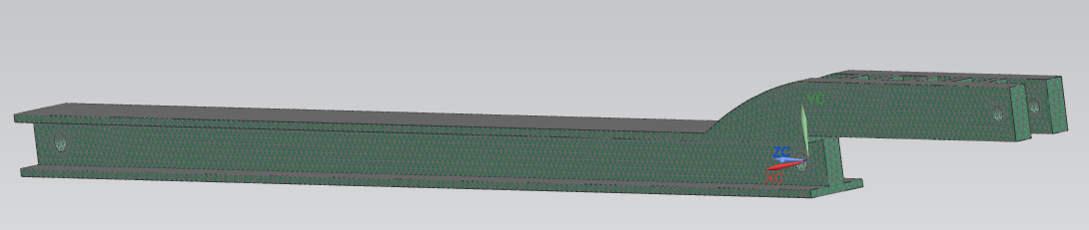

Figure 6 - Stick Design

The bucket in Figure 7 has been approximated as a shelled triangular prism. For simplicity it is assumed that the bucket weight is 100 kg.

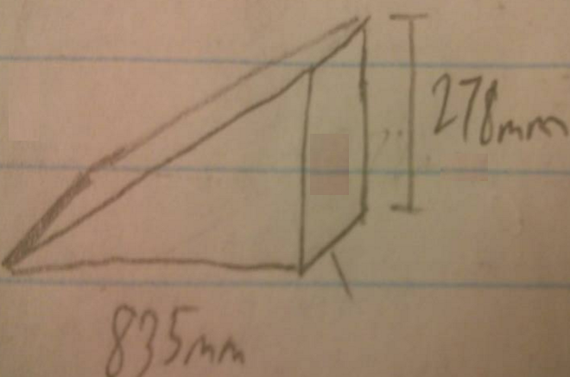

Figure 7 - Bucket Dimensions

### 2B Cylinder Force Requirements

The following are the given specifications for which the excavator must adhere to:

* Operating Weight: 5000kg
* Bucket Capacity: 0.15m3
* Arm/Stick Max Digging Force: 24kN
* Bucket Max Digging Force: 35kN

The following calculations will be based upon the above specifications only. Once the required cylinder forces are found, a factor of safety of 1.5 will be applied.

### 2B-1 Boom Cylinder Force Requirements

Before the maximum force required by the boom cylinder was determined, the mass of the bucket full is found assuming it is full of dirt. This is due to the fact the bucket full of dirt will produce a moment about the boom’s axis of rotation and therefore will need to be supported by the boom cylinder.

The volume of dirt which can be held by the bucket it set as 0.15m3. Taking into account the density of dry dirt, given as 1200kg/m3, the total mass of the bucket when full is 2080 kg.

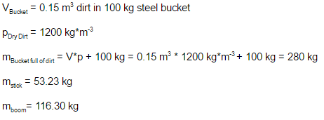

The center of gravity, as stated above, is approximated to be at the midpoint of the boom (1.26 m from axis of rotation); producing a moment about the boom’s axis of rotation. As well, the center of gravity of the arm is approximated to act at the midpoint, producing a moment about the booms axis of rotation.

The bucket of dirt will be considered as a point mass at the end of the stick; producing a third moment about the boom’s axis of rotation. If the bucket of dirt is held at a max radius, as depicted in Figure 8, the cylinder will be situated at a greater angle and will require less force to support the system. Therefore, the limitation of the boom is set to not move below its horizontal axis. Hence, the imaginary line connecting the pivot points on the boom will not be allowed to be at an angle below the horizontal plane. In the boom’s lowest position, the angle of the boom cylinder with the horizontal plane will be at its smallest. At this position the moment produced about the boom’s axis of rotation was discovered to be the greatest; therefore, this position was used to calculate the maximum required boom cylinder force.

The following calculations give the moment produced when bucket is full of dirt, stick, and boom are fully extended horizontal to the ground.

Force on boom cylinder:



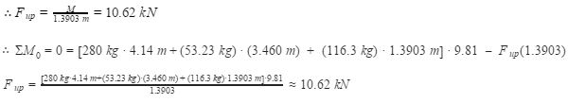

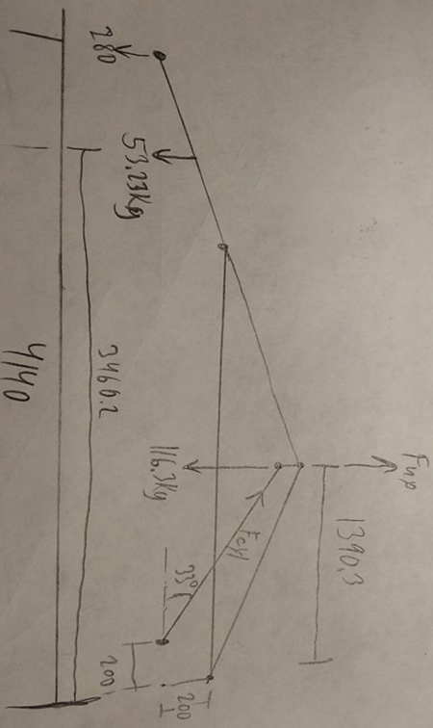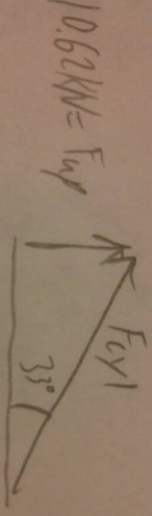

Figure 8 - System Position when experiencing Max Boom Cylinder Force

Figure 9 - Boom Cylinder Force



### 

### 2B-2 Bucket Cylinder Force Requirements

Force on bucket cylinder:

|  |  |
| --- | --- |
| https://lh6.googleusercontent.com/oX4pPeBFJwCkvZ64unEeO5ulaSE9hpx2bwDTON6jLb3eHvVQS2wgh4bWQykefamomDehdt0VA5k-739xxDwXvcIrvwsdkongWeNUm2tOCFRpbw-aSBYnVo7c02SZ82zECC9mBxI  Figure 10 - Bucket Cylinder Schematic | https://lh3.googleusercontent.com/SFqBKY9NoqdhM6TpQDaX9RSPwwQApbiVdotfymURYc0n9eBza_8x1WSwpW3IUpbi2iEHNvtkoOG4sfMKSTlcq4Dg4qUVLEz1K2oGoeiIFNiJZX3M9ciHvmqx0va2KIbpMQIsts8  Figure 11 - Bucket Cylinder Force |



### 2B-3 Stick Cylinder Force Requirements

The following schematic shows the stick positions desired. The system is designed so that the stick will not exceed the 90-degree position with the horizontal plan. At this max curl position, it can be seen the length of the extended cylinder will total (from end to end) 1147mm. When the arm is positioned parallel with the boom, the cylinder length will be 604.7mm. When the stick is at 22 degrees with the horizontal plane, the extended tip of the bucket will reach its required position. It is at this position the stick cylinder will need to produce the maximum force.

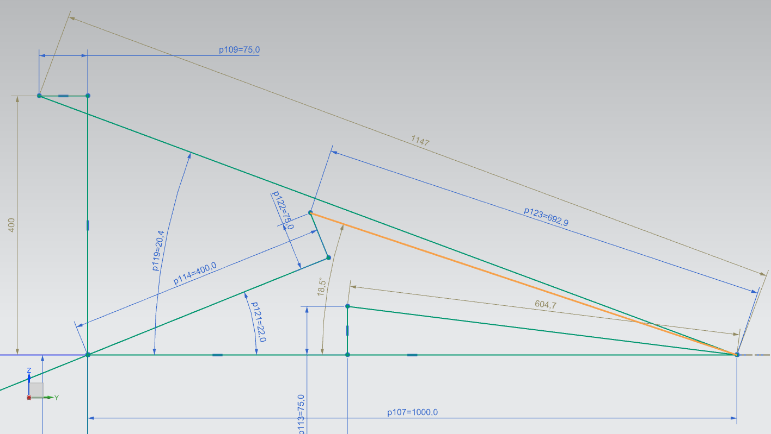

*Figure 12 - Stick positions and Cylinder orientation when producing Max digging force.*

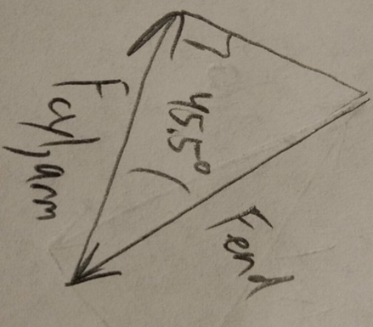

Figure 13 - Stick Cylinder Force

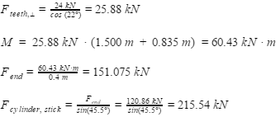

### 2B-4 Cylinder Stroke Calculations

#### Stick Cylinder

Stroke = 1147.0 mm - 604.7 mm = 542.3 mm

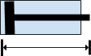

Shortest length = 604.7 mm

https://docs.google.com/drawings/u/1/d/sXDUNVCAgGpdJSVAbLWq2wA/image?w=113&h=46&rev=26&ac=1

Longest length = 1147.0 mm

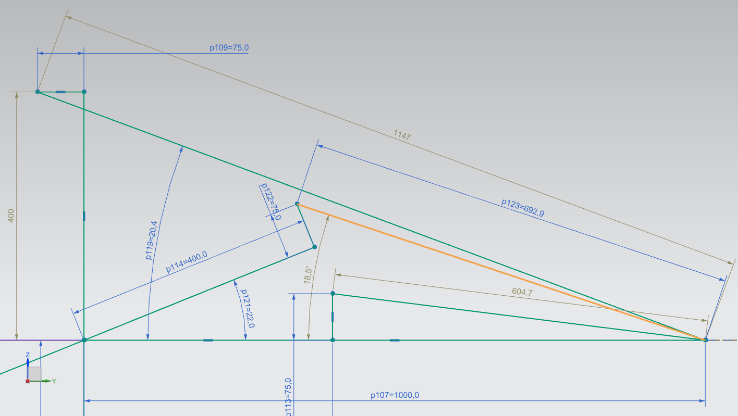

Figure 14 - Stick cylinder Lengths

#### Bucket Cylinder

Stroke = 979 mm - 650.7 mm = 328.3 mm



Shortest length = 650.7 mm

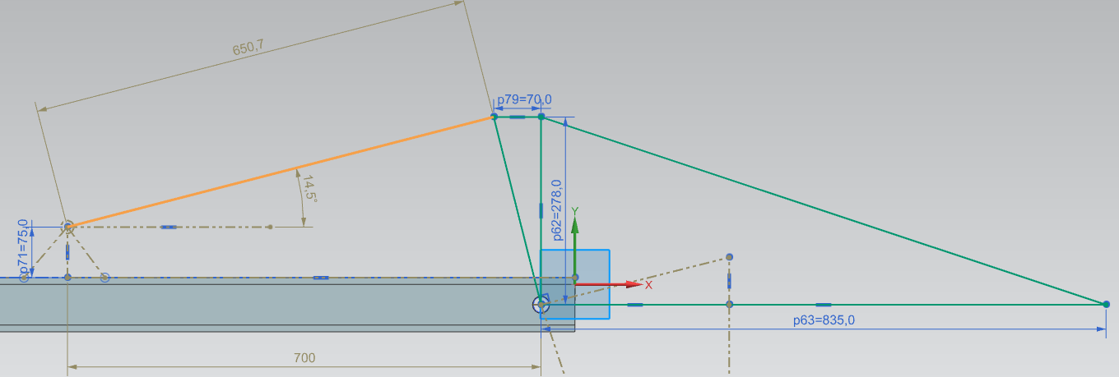

Figure 15 - Bucket Open

https://docs.google.com/drawings/u/1/d/s3LQg-KXsOCwRa_Rf-C3sVQ/image?w=113&h=46&rev=1&ac=1

Longest length = 979 mm

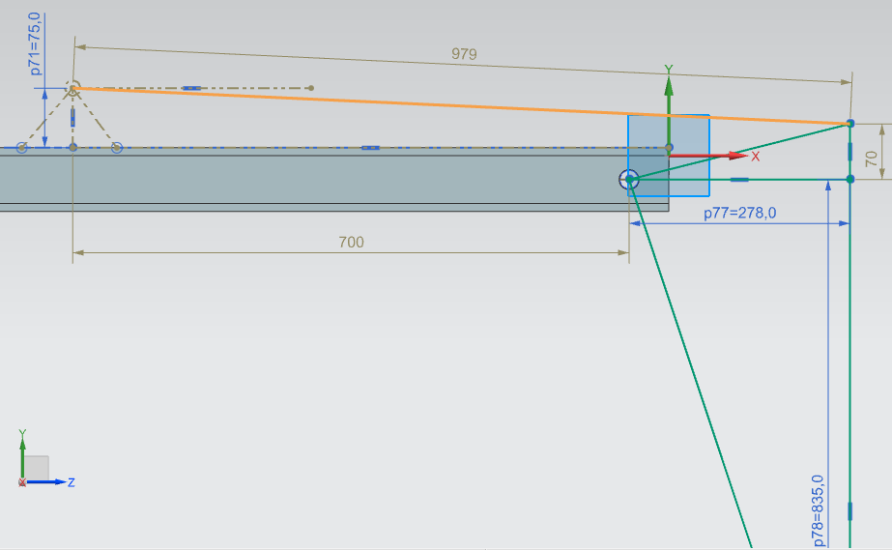

Figure 16 - Bucket Closed

### Boom Cylinder

Cylinder housing length = 1770.4 mm / 2= 885.2 mm long



885.2 mm

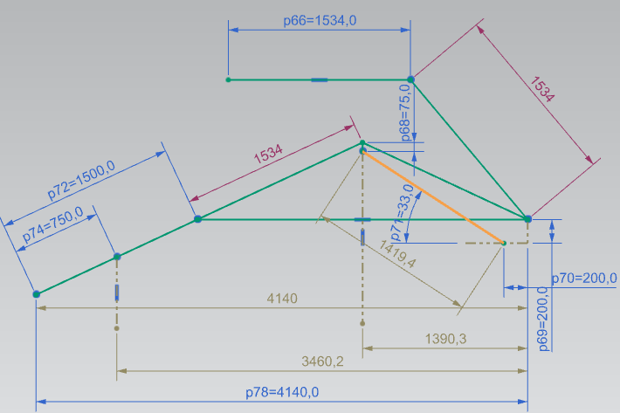

Figure 17 - Boom in Lowest Position

https://docs.google.com/drawings/u/1/d/sQsNlkW4cMhGAq4q3krpzWQ/image?w=113&h=59&rev=18&ac=1

1419.4 mm - Shortest length position set for cylinder/piston.

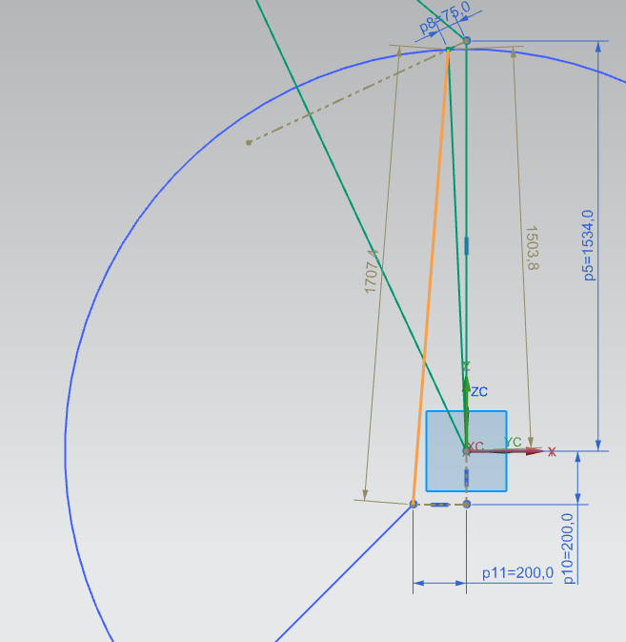

Figure 18 - Boom in Highest Position

https://docs.google.com/drawings/u/1/d/s1zWI7wvvT6NzkCjpyzjikg/image?w=113&h=46&rev=1&ac=1

1770.4 mm - Longest length

### 2C Pump Selection

The most common type of pump on the mobile application is a gear pump. The piston selected requires a maximum flow rate of 120.6 LPM, therefore a suitable pump to provide this flow rate at a reasonable rate, i.e. 2000 rpm, would be the external multiple gear pump from Rexroth Bosch Group Series B which is 10 of the 6.3 cc/rev pump in series connected to each other to provide 63 cc/rev.

The volume per revolution is necessary to supply the 120.6 LPM required by the layout of the piston. The extension and retraction speed of the piston according to maximum flow rate of each cylinder.

|  |  |  |
| --- | --- | --- |
| Maximum flow rate of bucket cylinder | Qv in: 73.6 LPM | Qv out: 50.5 LPM |
| Maximum flow rate of stick cylinder | Qv in: 120.6 LPM | Qv out: 82.5 LPM |
| Maximum flow rate of boom cylinder | Qv in: 18.7 LPM | Qv out: 12.6 LPM |

The horsepower and torque need to drive the pump

### 2D Fittings and Head loss

Figure 19 - Hydraulic Plumbing with Hose

The maximum pressure the cylinder can take is 16 MPa = 2300 psi. The flex hose to be used must be able to take on that pressure. The hose chosen was aeroquip-fc194-aqp: 194-08 with inside diameter 0.5 inch.

There will be three different sets of hoses which will be required, one for the bucket cylinder set, another set for the stick cylinder, and finally the boom cylinder; as shown in the Figure 19. Based on the calculation in section 2A and the drawing above, the cylinder on the right is the boom cylinder which will rise and low the boom, middle cylinder which is mounted in the boom will control the stick action. This cylinder will actually be placed on the top side of the boom. The left cylinder which is mounted on the stick controls the bucket action. The length of the flexible hose will be extending from the machine and going in and out each cylinder. The hose length for right cylinder will be 910 mm for retracted end. There is no extended end since it is close to the machine and can be neglected. The hose length for middle cylinder will be 1560 mm for extended end, and 2180 mm for retracted end. The hose length for left cylinder will be 3080 mm for extended end, and 3730 mm for retracted end. The hoses have been made slightly longer to accommodate an increase in length as pressurized fluid enters them.

The head loss within the flexible hose will be calculated with SG = 0.9 and kinematic viscosity of 100 cS.

Flow rate of the pump can supply is 120.6 LPM that mentioned in Section 2C.

The flow rate conversion: 120.6 LPM =31.84 GPM = 0.071

Fluid velocity is discovered to be:

Reynolds number Is in laminar region

Head loss for 910mm pipe length

Head loss for 1560mm pipe length

Head loss for 2180mm pipe length

Head loss for 3080mm pipe length

Head loss for 3730mm pipe length

The greatest head loss through the hose will be found in the hose going all the way to the bucket cylinder, the pressure drop due to this loss being:

Head loss inside the machine from the circuit is shown later in Figure 20. In order to keep the flow rate and Reynolds number to be the same, the hard pipe uses 0.5 inch inside diameter as the flexible pipe. The hard pipe has to go from pump to the exit point where will go to flexible pipe. In the process, fluid has to go through: 3 Tee junctions,5 90 elbows, 1 DCV, 1 check valve, 1 flow control valve, in addition to all the piping length.

The k valve for each component is (reference 3): K for check valve = 4, K for DCV = 5, K for gate valve = 0.19, K for 90 elbow = 0.75, and K for Tee junction = 1.8

Total head loss in one of the branch of the circuit is as follows:

Which is resulted in 13.6 psi drop in the boom circuit, stick circuit and bucket circuit.

### 2E Hydraulic Cylinder Dimensions

The cylinder will be using Bosch Rexroth CDL1 MP5 which has maximum pressure at 16 MPa. Size of the cylinder is based on the force used are come from section 2A and with safety factor of 1.5.

The diameter that required to retain the 16 MPa is calculated below:

As a result, the selected cylinder has to be at least the numbers obtain above.

The actual cylinder diameter is chosen to be 125mm for bucket cylinder, 160 mm for stick cylinder and 63mm for boom cylinder.

With the new cylinder selection, the pressure on each cylinder need to be recalculated as:

The velocity for extend and retract can be found base on equation

After further calculation, it was found out that because the flow rate provide by the manufacturer is fine-tuned, hence all the velocity is the same across all the cylinder in extend and retract to be 9.9cm/s

### 2E Safety valves

The safety valve will be using flow control valve and check valve and pressure relief valve.

# 3- Design of the Hydraulic systems

### 3A Hydraulic Schematic Diagrams

The full schematic diagrams are a combine of Figure 19 and Figure 20. The pipe/hose length and all the elbow are shown in Figure 20 at the lower circuit, the other two circuits will be configured the same.

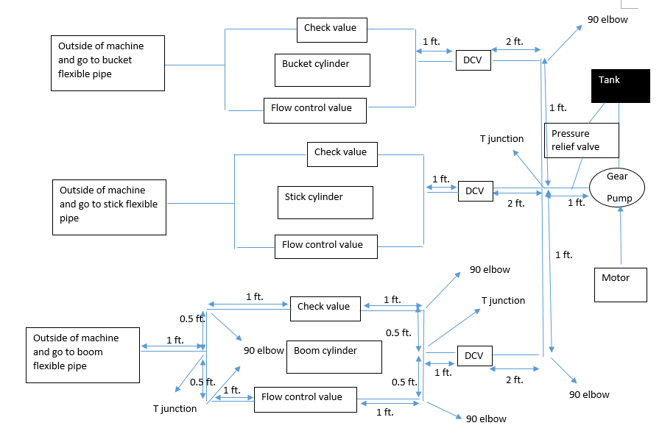

Figure 20 - Hydraulic Schematic Diagram

### 3B Selections of DCVs for Joysticks Application

The left joystick controls the boom to raise or lower. The boom raise when the cylinder extends and lowers when the cylinder retracts. The right joystick controls both the stick and the bucket. The stick will curl in when the stick cylinder extends; and the stick will extend out when the stick cylinder retracts. The bucket opens (releases soil) when bucket 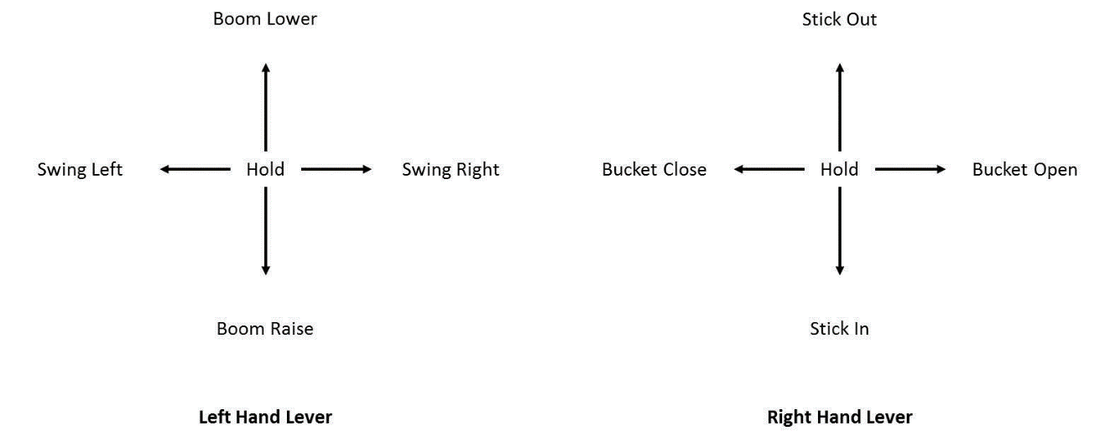cylinder retracts and the bucket closes (holds soil) when bucket cylinder extends. The control levers will be like the figure below.

Figure 21 - Typical Joystick Configuration

The excavator swing action is not within the scope of this project, therefore only three cylinders are focused on for controlling the entire stick operation.

The joystick design is show in Figures 22 through 24:

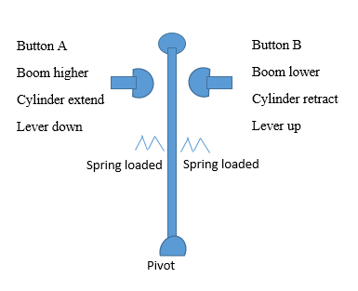

Figure 22 - Left Joystick (forward/backward) to control Boom Action

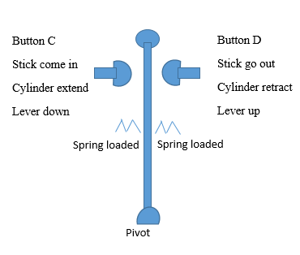

Figure 23 - Right Joystick (forward/backward) to control Stick Action

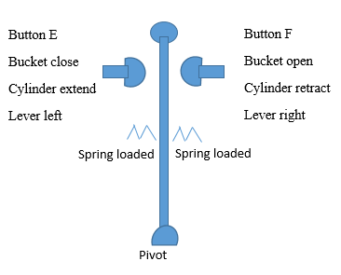

Figure 24 - Right Joystick (left/right) to control Bucket Action

The DCV design is shown the following figures:

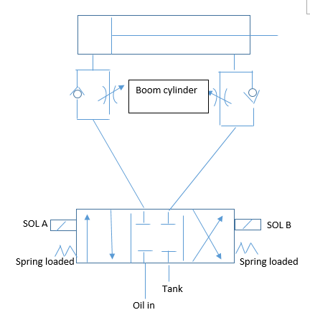

Figure 25 - Boom cylinder react to joystick action with button A and B

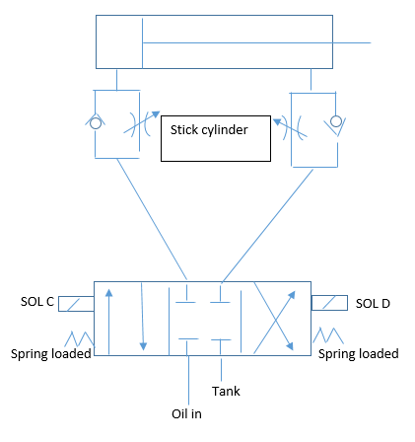

Figure 26 - Stick cylinder react to joystick action with button C and D

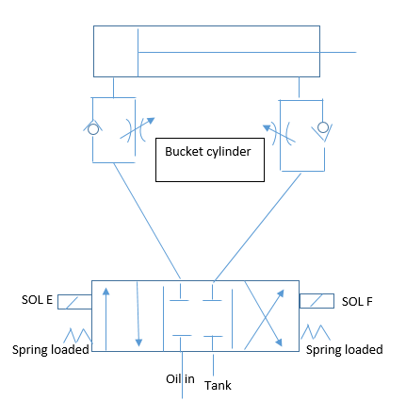

Figure 27 - Bucket cylinder react to joystick action with button E and F

The circuit to control all three cylinders and DCV with joystick is shown in Figure 28. 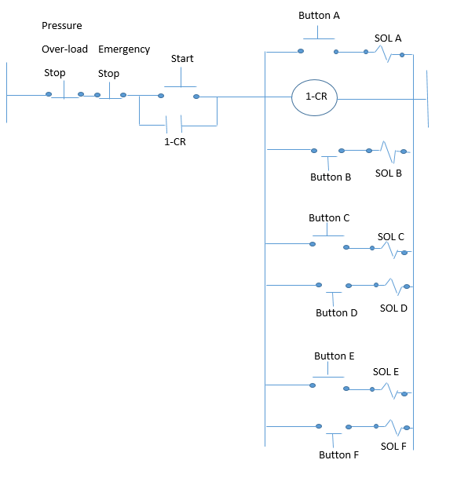

Figure 28 -Basic circuit with solenoid and button which the joystick can active.

Circuit break down:

The DCV using is HY11-3500/UK with ordering code D3MW008C is built to withstand a flow rate up to 150 LPM. In Figure 28, operator press start button to start machine. Immediately coil relay 1 will activate, and the start button will be bypassed. Now only the stop button can stop the entire circuit and machine immediately (safety function). In Figures 23 through 27, the joystick and the DCV are both spring loaded on both side. When either of the joystick pressed any of the buttons, that button will active the corresponding solenoid in Figure 28, and the solenoid will push the corresponding DCV; resulting in the respective cylinder extending or retracting. When the operator lets go the joystick, the spring loaded DCV will push back to center position as the solenoids controlling it will deactivate. Without a solenoid being activated, there is no force provided to keep the DCV from going back to the center position. Once settled in the center position the cylinder will in hold in its current position.

### 3C Advantages and limitations of your design

From a kinematic point of view our stick design is flawed as it cannot curl to the extent shown in Figure 1. There were issues with the positioning of the stick cylinder to produce the curl in position depicted and decided to limit the curl in of the arm. The boom has also been limited in its rotation path for simplicity of finding the max boom cylinder forces. Due to limitations, the digging depths depicted in Figure 1 were not attainable.

A concern regarding the hydraulic system lies in the high flow rate used. This made it very difficult to find compatible components which would suit the high flow rate application.

The tandem screw pump chosen to be used is another concern. This pump as described before is made up of 10 smaller pumps in series. If a pump in the middle of the series fails, the pumps after will no longer pump the oil. Servicing this style pump would be difficult due to limited space.

A safety feature that should have been incorporated was an emergency shut down when during over pressure scenarios. This could be as simple as including a pilot line from the cylinders to actuate a solenoid which would cut power to the system. Pressure relief valves are incorporated to combat over-pressure scenarios, but another safety should be incorporated.

### 3D Maintenance schedule

The maintenance schedule is divided into two parts: hydraulic fluid and hydraulic system.

First, for hydraulic fluid:

1. Control working temperature
2. Check for unusual oil/fluid odor
3. Check the oil filter every day to clean the trapped particle
4. Keep the oil/fluid record
5. Check hydraulic hoses, tubing and fittings for any possible leakage
6. Clean the inside of a hydraulic reservoir every month

Second, for hydraulic system (reference 1)

1. Check for leakage on the pump
2. Check for leakage on cylinder
3. Check for the flow in pressure relief valve
4. Check for clogged valve and pipe or house
5. Changing the return or pressure hydraulic filter
6. Obtaining a hydraulic fluid sample
7. Checking hydraulic actuators
8. Checking and recording hydraulic pressures
9. Checking and recording pump flow
10. Checking and recording voltage reading to proportional or servo valves
11. Checking and recording vacuum on the suction side of the pump
12. Checking and recording amperage on the main pump motor
13. Checking machine cycle time and record.

# 4- Component selection

When designing the fluid power system for this excavator the main components needed to make our design work were chosen from various tier one supplier catalogues. The main components chosen along with their reason of choice and catalogue numbers are described below.

### Hydraulic Cylinder

There are three different sized hydraulic cylinders that were chosen for the excavator. Each cylinder was chosen from Rexroth, a division of Bosch, with standard size piston diameter and custom stroke lengths made to order. The mounting style for each of these pistons is referred to as CDL1-MP5 which is displayed in figure 29 below.

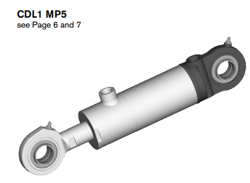

Figure 29 - CDL1-MP5 Piston

This particular design allows the cylinder to pivot with the moment arm as the stick and boom angles change. In accordance to the calculations from section two of this report, the bucket cylinder must be at least 109.69mm in diameter with the incorporated safety factor of 1.5. Similarly, the stick cylinder and boom cylinder had minimum piston diameters of 160.40mm and 48.24mm. These diameters were determined with a maximum working pressure provided by the pump of 16 MPa which is also the maximum nominal pressure of the pistons produced by Rexroth. From the diameters calculated the bucket cylinder was chosen to be 125 mm in diameter, the stick cylinder to be 160mm in diameter, and the boom cylinder to be 63mm in diameter. The three diameter sizes listed above are standard piston sizes provided by Rexroth. With the cylinder diameters chosen being equal to or larger than required, it allows for the factor of safety to be met as well as the piston working pressure to be reduced. Figure 30 below tabulates the main specifications of the type of piston chosen.

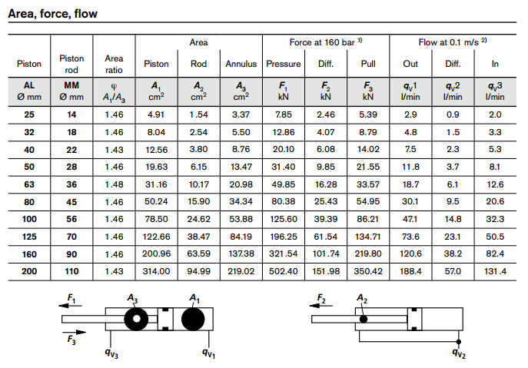

Figure 30

Once again regarding the calculations from section two of this report, it can be seen that the maximum force acting on the bucket, stick, and boom cylinders are respectively 151KN, 323KN, and 29KN. Each cylinder diameter selected earlier with respect to figure 30 shows that the force produced at 16 MPa or 160bar at least meets or exceeds the force with the 1.5 safety factor added. This will allow the cylinders to perform many duty cycles with reduced fatigue wear. The cylinder’s flow rate in and out of the housing was also considered in parallel with the pump selection to make sure the pump with the added head loss can produce the flow needed to extend and retract the cylinders with the corresponding forces. Therefore the final requirements and order codes for each hydraulic cylinder is displayed below.

Bucket Hydraulic Cylinder: CDL1MP5/125/70/651D1X/B1CFUVWW

Stick Hydraulic Cylinder: CDL1MP5/160/90/605D1X/B1CFUVWW

Boom Hydraulic Cylinder: CDL1MP5/63/36/885D1X/B1CFUVWW

The ordering details for the pistons can be viewed in Appendix A.1

### Gear Pump:

The gear pump chosen for this application is an external gear pump which also comes from Rexroth, a division of the Bosch Group. This particular pump needed to produce a flow rate that could produce enough flow to the pistons to operate them at maximum force with an added safety factor of 1.5. From the calculations and the piston specifications outlined previously, a max flow rate of 120.6 liters per minute must be produced to extend the piston with the highest force. From this value it was determined that the AZPB-3X external gear pump from Rexroth Bosch Group with a 63 cubic centimeter volumetric displacement would provide a flow rate of 126 liters per minute at 2000 rpm. To obtain the 63 cubic centimeter per revolution displacement, ten AZPB-3X pumps would be needed in a multi-pump set up where each pump drives the next in series. Figure 31 shows the specific pump that can be set up in the tandem configuration.

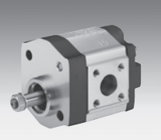

Figure 31 - AZPB-3X pump

The Rexroth gear pump in tandem producing a volumetric displacement of 63 centimeters cubed per revolution also operates at 16 MPa and only requires 2000 rpm to produce the flowrate needed for the system. This results in a reasonable horsepower and torque figure to drive the pump of 45.04 HP and 118.32 Lbs.-ft. In addition, Rexroth claims this particular pump has a long service life with reinforced shafts and cast iron construction making it ideal for use in heavy machinery. The order code for the standard multiple external gear pump is listed below and its order sheet can be found in appendix A.1.

AZPGG-22-4.0/4.0RHO20 20KB

### Directional Control Valve

The directional control valve that was chosen for the system is a 3 position spring loaded solenoid activated directional spool valve. The valve chosen is supplied by Parker Canada and is part of the D3MW series. The reasons for choosing this valve include the valve having a max flow rate of 150 liters per minute, a maximum pressure of 35 MPa and the solenoid activation. The 150 liter per minute rating is well above the max flow rate of the system being 120.6 liters per minute. This will allow the full flow from the pump to travel through the DCV with no limitations. The maximum pressure of 35 MPa is well above the system rating of 16 MPa, and the solenoid activated valves allow for joystick operation which is necessary for this application. As depicted in figure 32 below, there are 3 valves to allow the oil to both extend, retract and pause the flow going back and forth in the system.

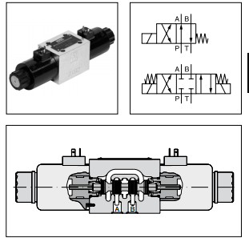

Figure 32 - D3MW DCV

In addition, the D3MW DCV from parker has high corrosion protection, robust design for heavy duty applications and standard EN175301-803 solenoid connecters. The Order code for this part is displayed below as well as in the catalogue order sheet in appendix A.1.

Parker Directional Control Valve: D3MW008C

### Flow Control Valve

The flow control valve selected for this system would be the one supplied by either Eaton Hydraulics, Festo Canada, or Parker Canada. According to product specifications a max flow rate of 120.6 liters per minute is needed on the stick cylinder, however; far less flow rate is needed to operate the bucket and boom cylinder. The application of this flow control valve with a port size of 0.5 inches and flow control capabilities from 12 liters per minute to 120 liters per minute would be ideal, however; this is hard to find. This range in flow is needed to safely operate each cylinder in the system since the flow requirements as mentioned earlier are different for each cylinder. Eaton Hydraulics does produce Custom flow valves for which similar models to what is required can be found. A flow control valve with manual adjustment is preferred as well as the valve having two-way flow. The order code range for the custom flow valve is stated below. The reference for this product Number can be seen in appendix A.1.

E-VLSC-MC001-E1_H

### Check Valve

The check valve for this system which is designed as a meter-in-meter-out system with the flow control valve will have a port in and port out of 0.5 inches as well to keep with the standard pipe chosen. The reason for the check valve in this system is to help act as a safety measure for when the flow from the DCV is stopped and returned to center position. When this occurs, if the crack pressure is set to match with the cylinder force, then it will help hold the load where the operator left it and reduce the pressure on the DCV thus reducing wear on more expensive components. The check valve selected can be custom made by either Parker Canada, Festo Canada, or Eaton Hydraulics.

### Engine

The Engine requirements needed to drive the pump include 45.04 horse power and 118.32 pound feet or torque. This type of power would be delivered by any industrial diesel or turbo diesel engine produced by a company specializing in heavy machinery. This is a reasonable number since most excavators use this type of engine to not only supply the fluid power system but to also drive the tracks to move the machine around.

# 5- Appendix A1

## Cylinder selection





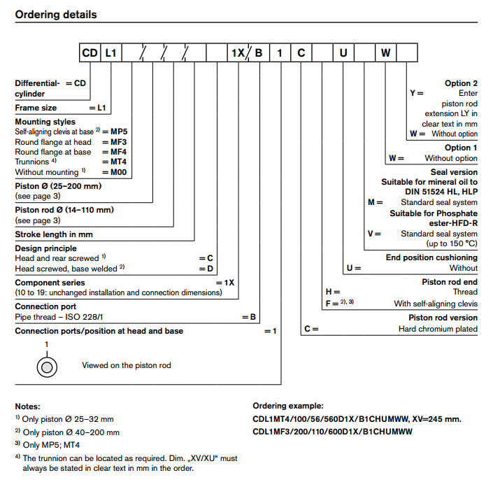

## Check valve

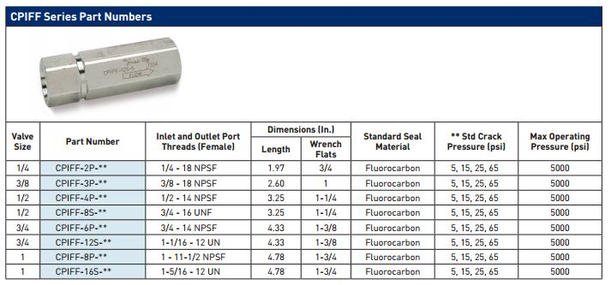

## Pump

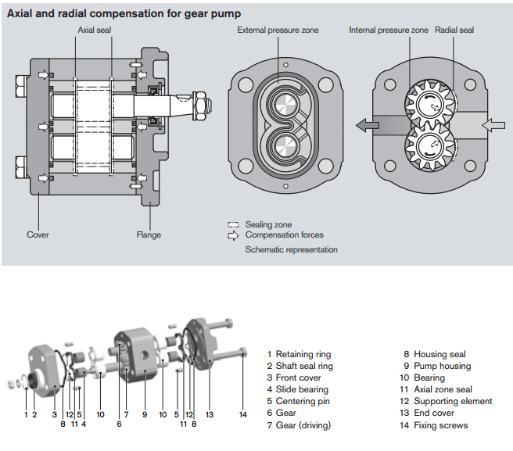

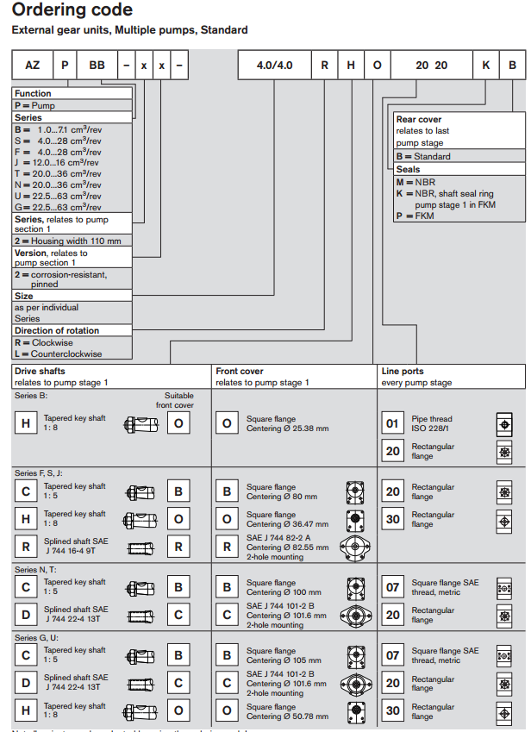

<https://uoit.blackboard.com/bbcswebdav/pid-744837-dt-content-rid-4034890_1/courses/20160173325.201601/re10088_2013-09.pdf?target=blank>

## Directional Control Valve

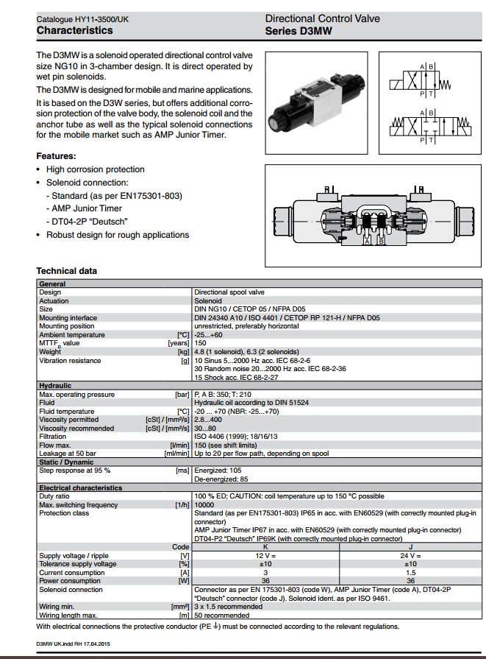

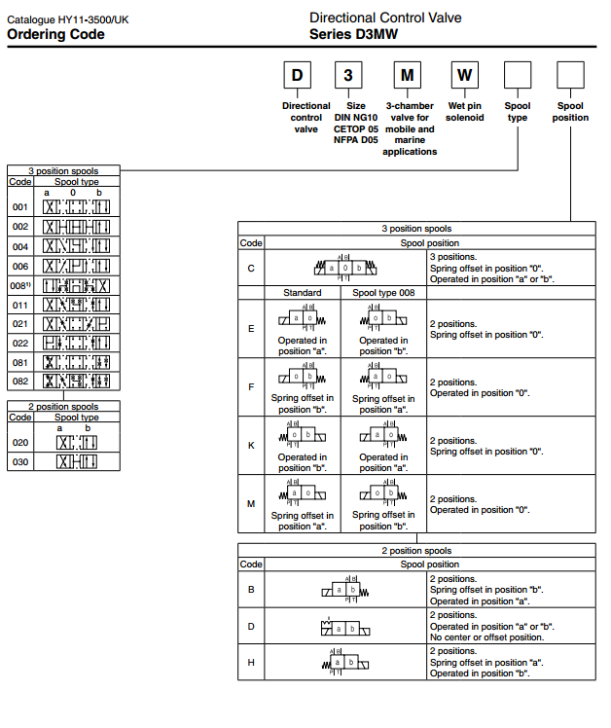

## Flow control valve

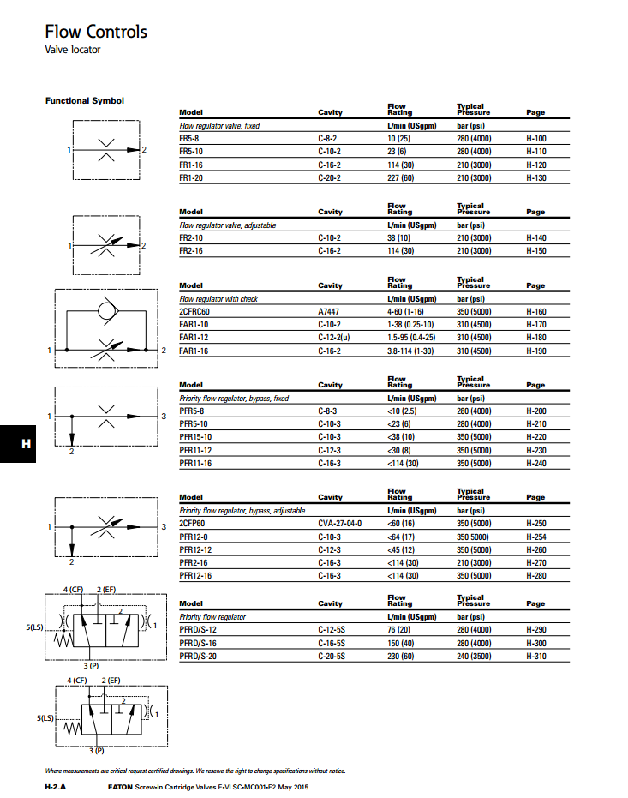

<http://www.eaton.com/EN/Eaton/ProductsServices/Hydraulics/Valves/Screw-InCartridgeValves/PCT_262526>

# 6- References

1, consideration regarding some preventive maintenance procedures for hydraulic systems by Ilie Octavian, POPP

2, <http://catalog.dunhamrubber.com/item/lic-hose-aeroquip-single-wire-braid-hydraulic-hose/aeroquip-fc194-aqp-hi-impulse-single-wire-braid/fc194-08>

3, Fluid Power with Application by Anthony Esposito 7ed